**EXPERIMENT 3.2**

**Student Name: Gaurav Kumar UID: 22MCC20177**

**Branch: MCA CC&DEVOPS Section/Group: MCD-1 A**

**Semester: 2ND Date of Performance: 11/05/2023**

**Subject Name: Software Testing Subject Code: 22CAH685**

**The task to be done:**

**What is Jira and JQL? What are the steps to perform JQL in Jira?**

# Steps for experiment/practical: copy and paste your code here/screenshots.

# What is JQL?

JQL stands for "Jira Query Language." It is a powerful query language used in Atlassian's issue tracking software called Jira. Jira is commonly used for project management, bug tracking, and issue tracking in software development teams.

JQL allows users to perform advanced searches and filter issues in Jira based on various criteria such as issue type, status, assignee, project, and custom fields. It provides a flexible way to create complex queries to retrieve specific sets of issues from the Jira database.JQL provides a versatile way to search and filter issues in Jira, enabling users to retrieve the information they need for effective project management and issue tracking.

**Structure of JQL query**

**<field><operator><value> Keyword <field><operator><value**

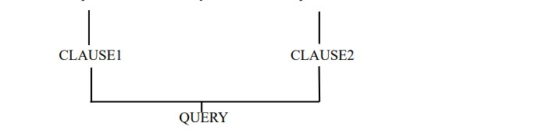

Example: Project = SOF AND issuetype= bug. Here SOF is the field that is the search criteria to filter the issue and to assign value of the field operator is used. Some of the operators are =, != , is not, is, not in ,in, was , was not, was in, was not in , changed. Keywords are logical operators like AND and OR.

**Write a Jira Query**

project = "E8” order by assignee DESC

**Steps to perform advanced issue search using JQL.**

1. Login to your Jira account.
2. Click on the ‘JQL’ or click on the search bar located on the top right corner.

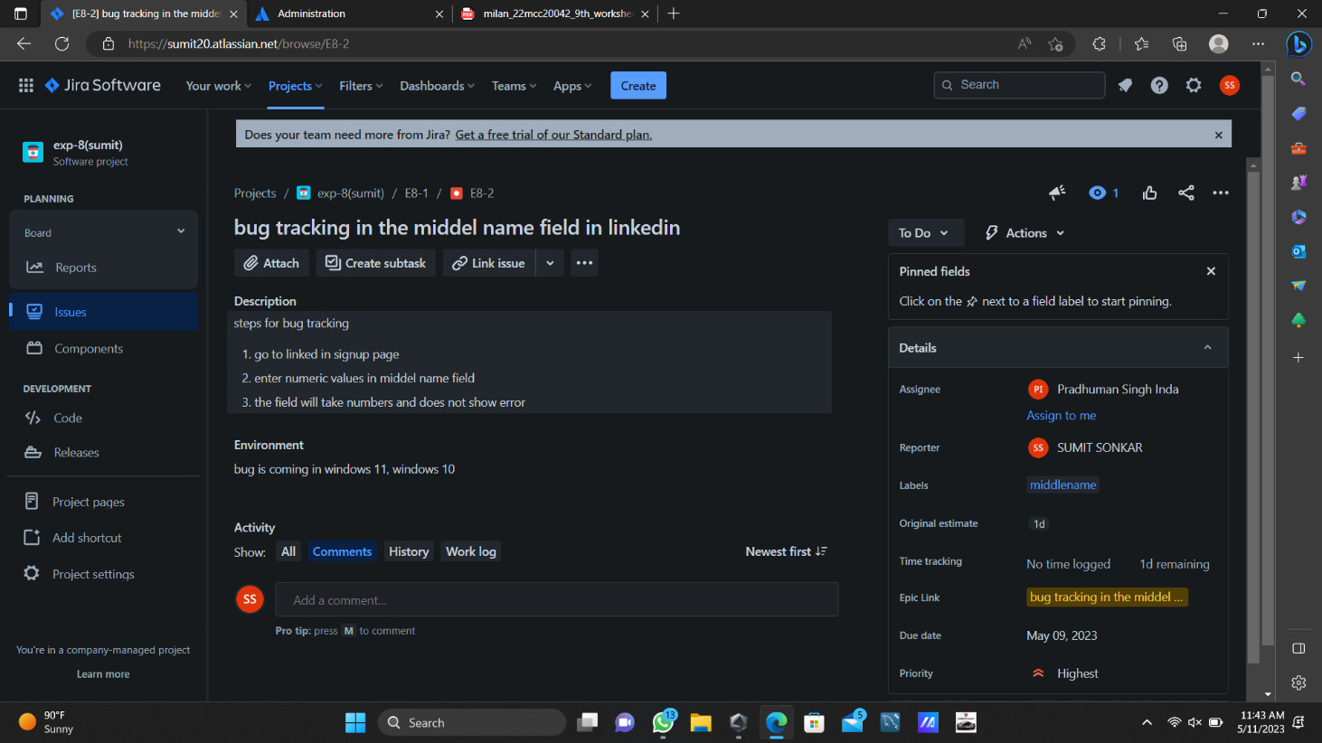

1. Click on advanced issue search.

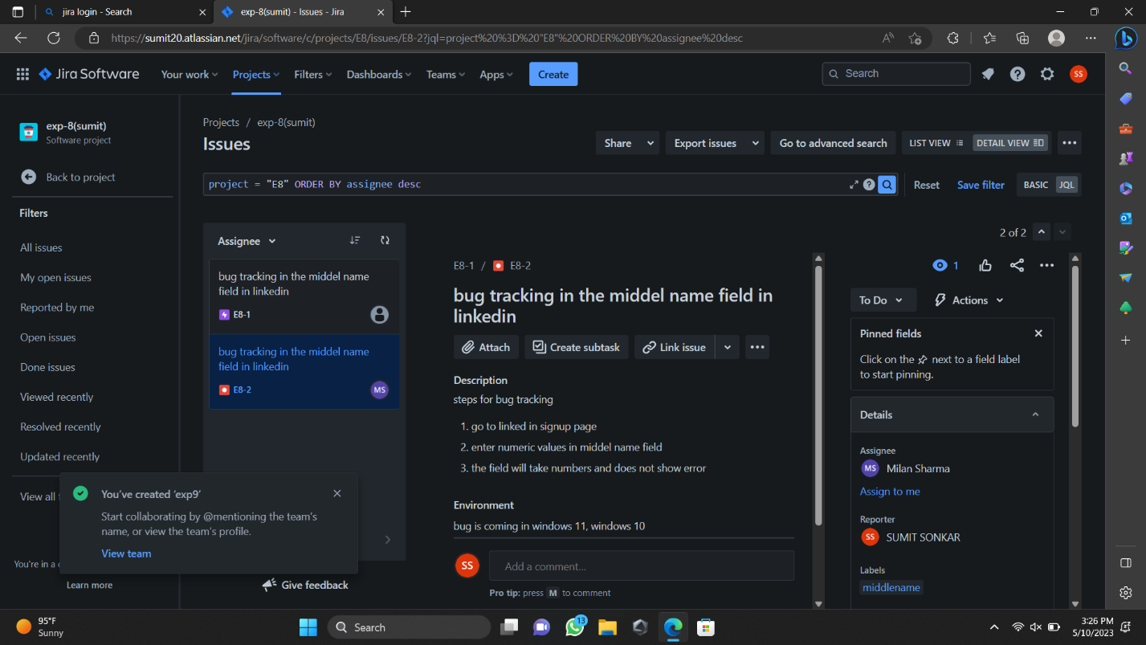

1. In the search bar if the filtering is basic click on the switch to JQL option to the right of the search button.
2. Enter your JQL query. As you type, Jira will offer a list of autocomplete suggestions based on the context of your query.
3. Now click search button and the issue based on the given criteria will be displayed and by entering your teammates email you can assignee the work to them.

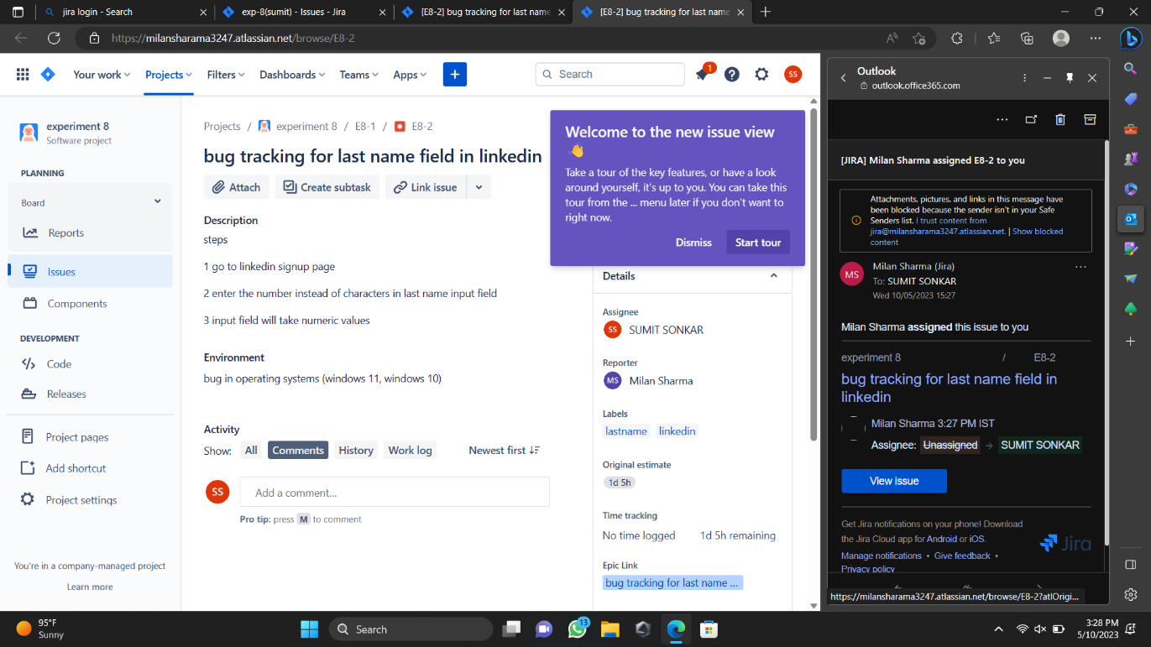

1. Your assigned work goes to your team member through their emails.

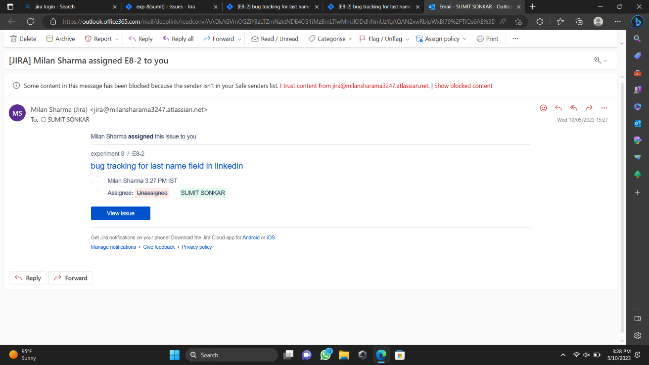

# Learning outcomes (What I have learned):

1. Learn about what is JQL.
2. Learn how to write JQL.

**Evaluation Grid:**

|  |  |  |  |
| --- | --- | --- | --- |
| Sr. No. | Parameters | Marks Obtained | Maximum Marks |
| 1. | Demonstration and Performance (Quiz) |  | 22 |
| 2. | Worksheet |  | 8 |